1. Scan for the machine using **netdiscover** 🡪

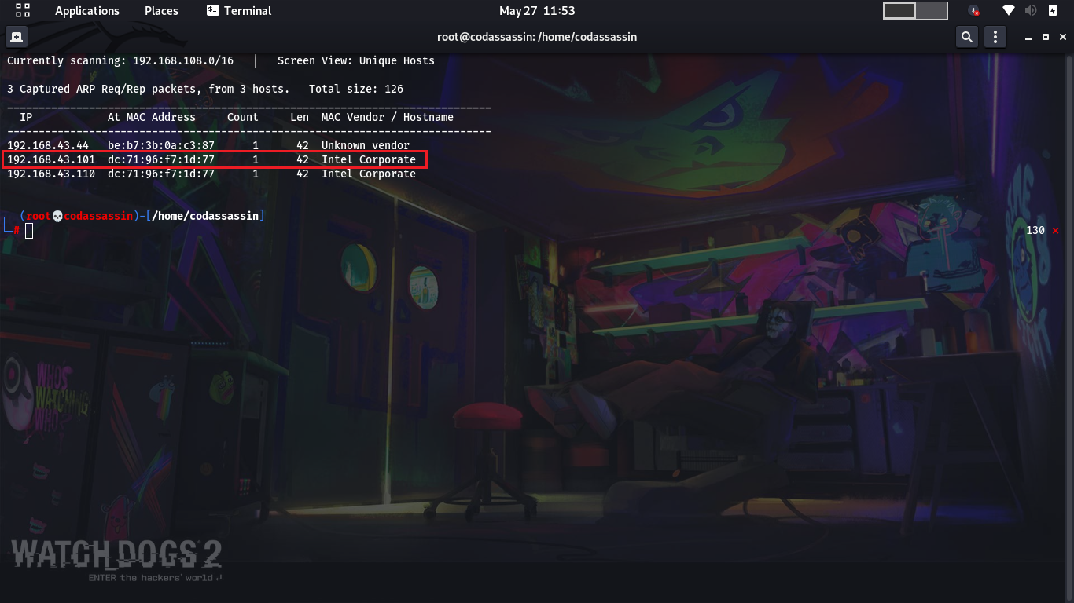

1. Scan for vulnerabilities in the machine using **nmap** 🡪

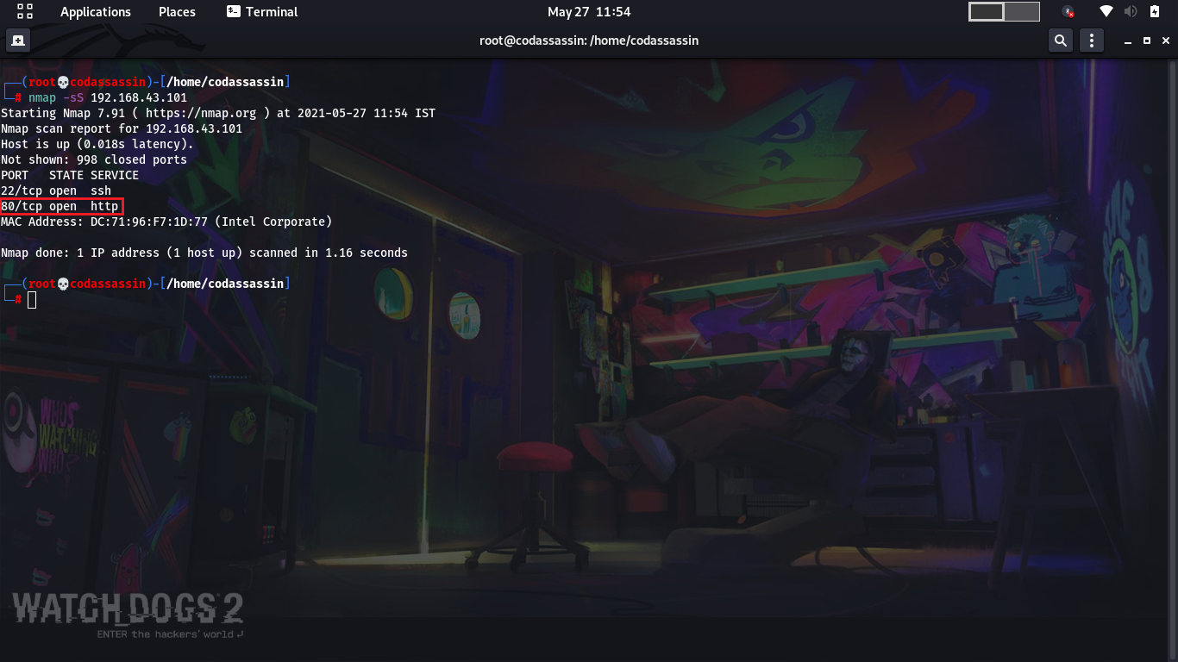

1. Since the port 80 is open running service http, so it is a website. Opening the website 🡪

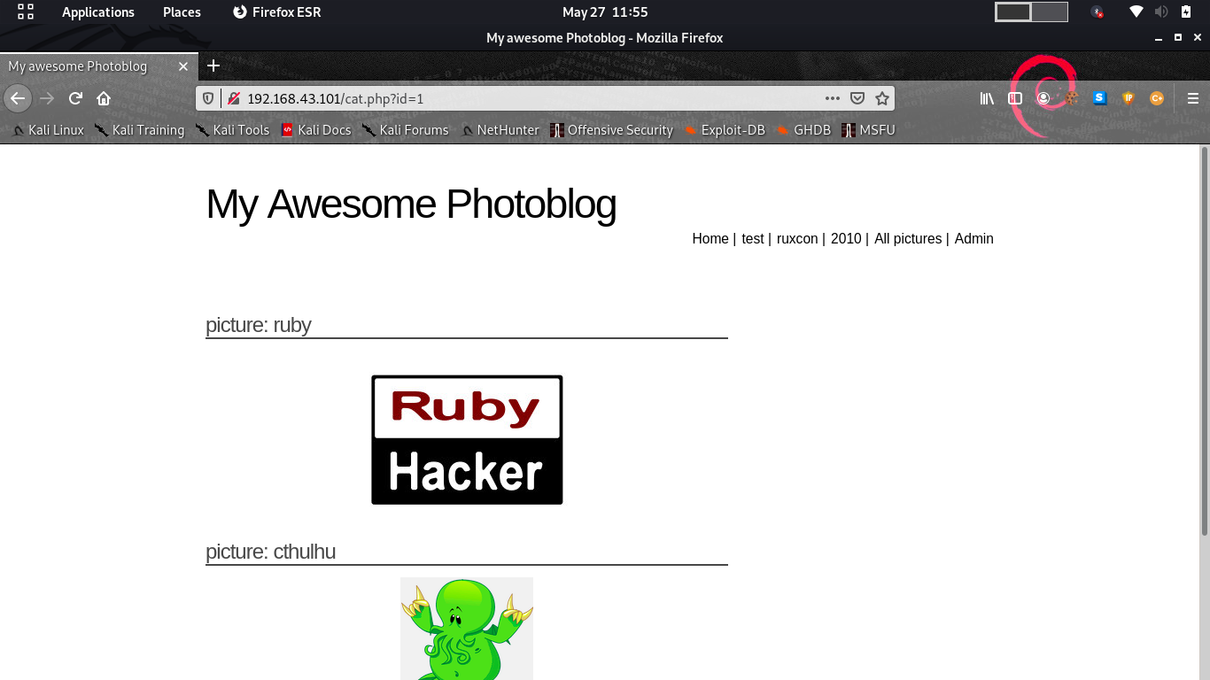

1. Using **sqlmap** to find if its vulnerable to sql-injection 🡪

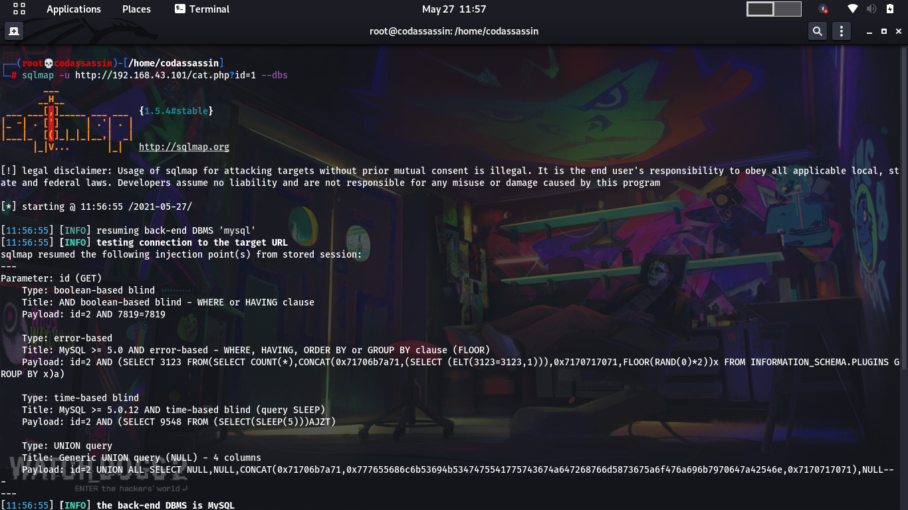

1. Opening and dumping the users data to extract admin details 🡪

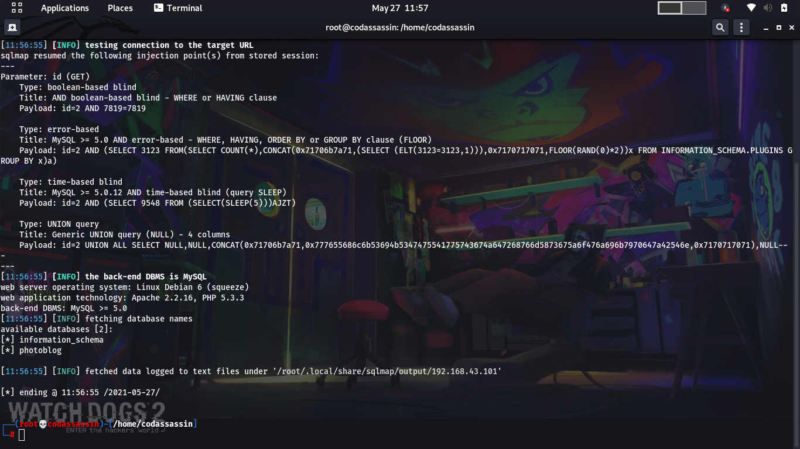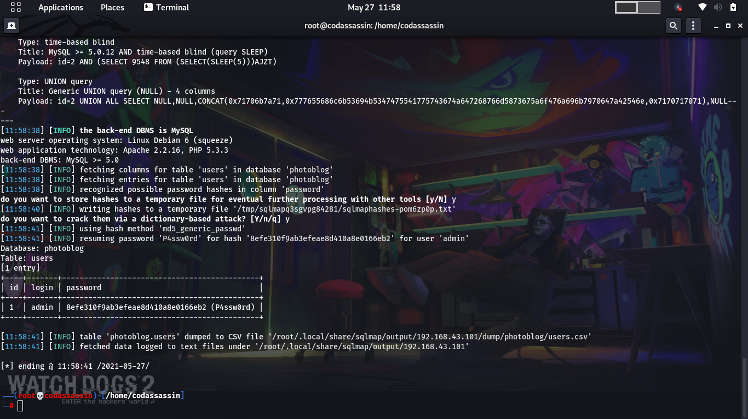

1. Putting the admin details to access the admin account 🡪

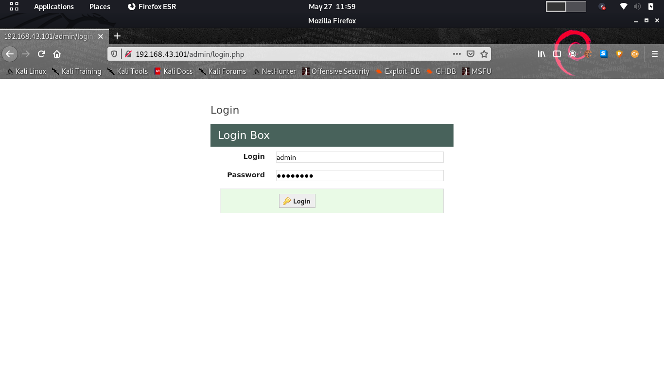

1. Customizing a php payload in order to listen on the attacking machine 🡪

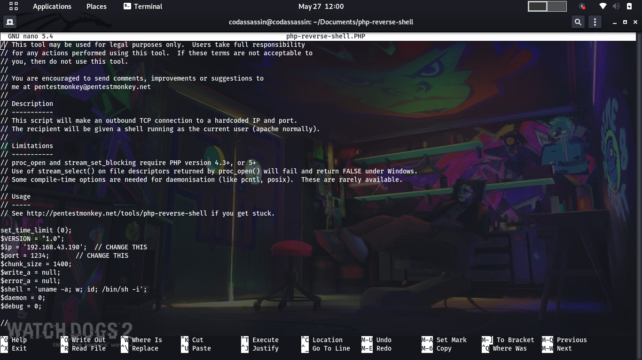

1. Adding the customized payload to the website using administrative privileges🡪

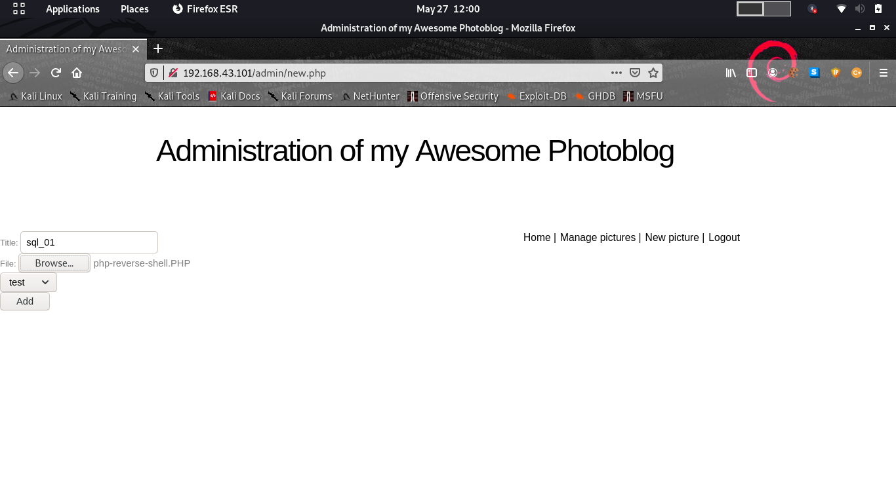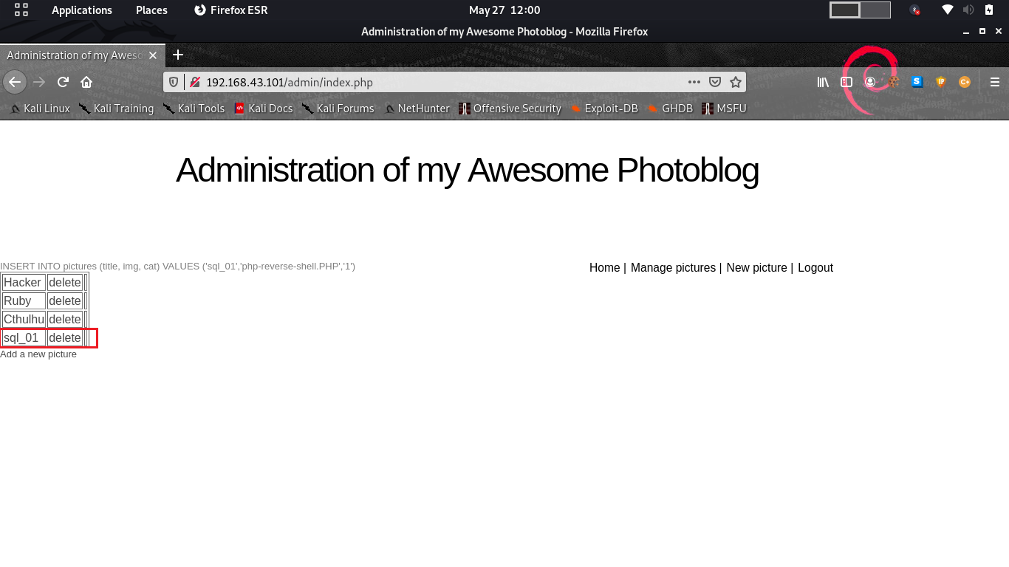

1. Setting up listener using **nc** on port 1234🡪



1. Adding injection commands on the browser panel🡪

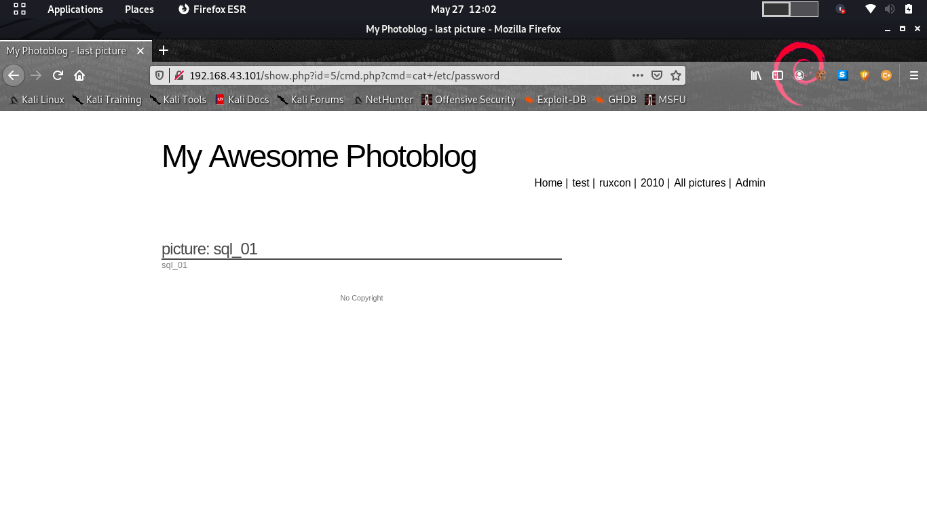

1. As we press enter the listener gets activated and listens on the port, we get full access to the machine/server/website 🡪

